WEDE5020
ST10524969

IIE Rosebank College
FULL NAMES : PHILILE FAITH KHUMALO

WEDE5020

Contents
WEDE5020 1
ORGANISATION OVERVIEW 2
Mission and vision statement 3
Target Audience 3
WEBSITE GOALS AND OBJECTIVES 4
Key performance indicators 4
Website features and functionality 6
Design and user experience (ux) 7
Technical requirements 8
Timeline and milestones 9
Budget 9
Reference 10

SOWETO TAXI SERVICES

ORGANISATION OVERVIEW

NAME: SOWETO TAXI SERVICES

Background of SOWETO TAXI SERVICES

This is the back-story to the emergence from the 1970s of today’s taxi industry. With the white minority regime and corporate South Africa unwilling to effectively spend on safe and affordable public transport for the majority of their workers, and retail outlet consumers, township entrepreneurs moved into the vacuum. Through the 1980s, the taxi industry emerged partly under continuous harassment from the authorities, partly with their approval.
From the outset, taxi operators inhabited a rough and tumble world, on the grey margins of the law. This industry, now consisting of perhaps 200,000 mini- and midi-buses (no-one knows exactly how many for sure), wasn’t advancement by way of affirmative action or black economic empowerment codes. It was boot-straps stuff. It was, and often remains, a Wild West blend of impressive entrepreneurial initiative and warlordism. Routes and taxi-ranks are controlled at times literally through the barrel of a gun.
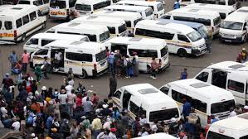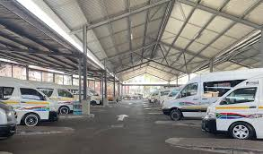

Mission and vision statement
To provide services such as tickets sales, booking services, changes in fair prices
Within the Soweto Taxi Services. We aim to introduce tickets sales and booking options
Into the transportation organisation known as Soweto Taxi Services through a website I shall
Compose. To be a trusted taxi services for the Soweto community, allowing driving convenience, safety and economic growth and making things easy for everyone to use a taxi.

Target Audience
1.Tourists
2.Students
3. Staff members
4. commuters
5. Pensioners

WEBSITE GOALS AND OBJECTIVES

. To inform users about current fair prices and scheduled changes in fair prising
. To allow users such as tourists, students, pensioners and staff members all based in Soweto to book or track taxis
. Offers special deals or discounts for students and pensioners
. Make it easy for tourists to navigate around Soweto
. Share news and updates about Soweto transport and collect feedback from users to improve service

Key performance indicators
Board for Soweto Taxi Performance [2026]
1. Financial and Digital Health
Focus: Using ticket systems instead of cash.
Eighty percent of daily travels are paid for with cash via a website and a mobile device or credit card.
Goal: 60% by the end of 2026 (based on transport routes in Soweto).
Payout Cycle Efficiency: It takes 24 hours for digital fares to travel to an owner's bank account.
2. Metrics for commuter, visitor, student, retiree, and employee satisfaction
The Soweto-Joburg corridor's dependability and safety are the main concerns.
All ranks in Soweto must wait at least ten minutes on average during peak hours.

safety Compliance Score: 100% of taxis within the Soweto region must undergo checks with tyre tread, brakes, and driver sobriety

WiFi Uptime: we hope to archive 75 % of the fleet providing active, free in-vehicle connectivity a major 2026 trend for student commuters

3. Operational Efficiency
Focus: Fleet management and route stability.

Vehicle Downtime (MTTR): 1 week minimum when vehicles withing the fleet are out of service to get repaired

Website features and functionality
Homepage (The Main Rank)
This is where everyone lands. It needs to be quick because people are usually checking it while walking or standing in line.
- Live Updates: A simple "What’s happening" bar. Like: "Bara Rank is full.
- Price Checker: A box where you put in where you’re starting and where you're going. It tells you the fare
- The Big Buttons: Three big icons: Find a Ride, Pay Now, and Safe Trip a button you can use to share to someone
About Us page
- Our Roots: A short story about how the Soweto taxi service was built.
- The mission: a section explaining why they offer these services and the drive behind this association
- The Promise: We keep the cars clean, the tyres fresh, and we treat everyone with care.
Contact Us
- WhatsApp Button: A direct link to chat with the office if you have a problem.
- Rank Map: A simple Google Map showing exactly where the ranks are
- Give Feedback: a place for customers to place reviews

Design and user experience (ux)
Soweto Taxi Services: Website Sitemap
[Level 1: The Entrance]
- 1.0 Homepage (The "Main Rank")
  - Live Route Ticker
  - Fare Calculator Tool
  - Quick-Action Buttons (Pay, Hire, Help)
[Level 2: Main Navigation]
- 2.0 About Us (Our Story)
  - 2.1 Our Heritage & History
  - 2.2 The "Captains" (Driver Profiles)
  - 2.3 Safety Standards (Hlokomela)
- 3.0 Services (The Hustle)
  - 3.1 Commuter Routes (Daily Trips)
  - 3.2 Private Hire & Charters (Events/Funerals)
  - 3.3 Digital Wallet & Payments
  - 3.4 In-Taxi Wi-Fi Info
- 4.0 Contact & Support (The Link Up)
  - 4.1 Rank Map Directory (GPS Locations)
  - 4.2 Lost & Found Reporting
  - 4.3 WhatsApp Support Link
  - 4.4 Feedback & Shout-outs
[Level 3: Hidden/User Pages]
- 5.0 Portal Login
  - 5.1 Driver Dashboard (Earnings/Schedule)
  - 5.2 Owner Dashboard (Fleet Status)

Colour Scheme (The Palette)
We’re using high-contrast HEX codes to ensure readability in bright outdoor light:
- Primary Colour (Taxi Gold): #FDB813 — Used for main buttons and headers to grab attention.
- Secondary Colour (Deep Charcoal): #2D2D2D — Used for text and backgrounds to keep it looking professional and modern.
- Action Colour (Safety Green): #27AE60 — For "Payment Successful" screens and "Go" buttons.
- Background (Soft Grey): #F4F4F4 — To keep the site looking clean and not too "heavy" on data/battery.
Typography (Font Choices)
- Headings: Montserrat (Bold) — It’s a geometric font that looks "tough" and reliable.
- Body Text: Roboto (Regular) — The standard for mobile apps because it’s super clear even on small screens.
- Hierarchy: * H1 (Titles): 24px Bold
  - H2 (Routes/Prices): 18px Medium
  - Body: 14px Regular
Layout and Design Approach
- Card-Based Layout: We’ll use "cards" to group info (like a card for a specific route or a card for a news update). This makes the site easy to scan.
- Minimalist Interface: No unnecessary "fluff." Every pixel should serve a purpose—getting the user to their destination.
User Experience (UX) Considerations
- The "One-Handed" Rule: Since users are often carrying bags or holding onto a rail, all key navigation is placed in the "Thumb Zone" (bottom 30% of the screen).
- Low-Data Icons: We’ll use SVG icons instead of heavy images to save the user's data.
- Feedback Loops: The phone should give a small vibration (haptic feedback) when a payment goes through or a button is clicked, so the user knows it worked.

Low-Fidelity Wireframe (Structure)
- Top Bar: Logo and a simple "Settings" cog.
- Hero Section: A big search box titled "Where to?" with a "Check Price" button.
- Status Ticker: A #FDB813 yellow bar that scrolls with live rank news.
- Action Grid: 4 large buttons for Private Hire, Wallet, Map, and Help.
- Footer: Simple icons for Home, Profile, and History.
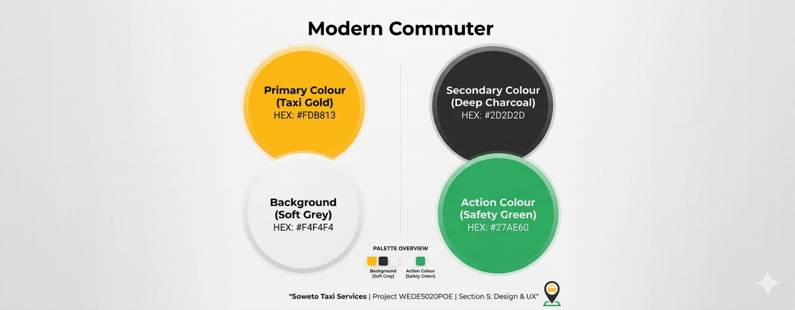

Technical requirements
In making this website we will be making use of HTML from the backbone and structure, then we will make use of CSS for the design and overall look of the website then make use Java script for functionality and responses in terms of buttons etc. domains will be provided by Rosebank College.

Timeline and milestones
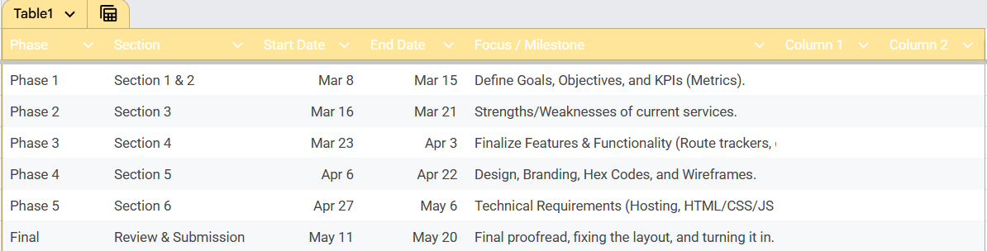

Budget
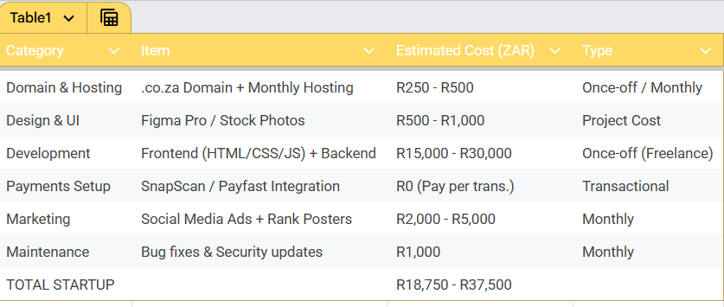

Reference
For the Website Design (Figma/Tools):
Figma. (2026). Figma visual design and prototyping tool (Version 116.15) [Computer software]. https://www.figma.com
2. For the Taxi Industry Safety/Standards (Hlokomela):
South African National Taxi Council (SANTACO). (n.d.). Hlokomela: Safe commute initiative. SANTACO Gauteng. https://www.santaco.co.za/hlokomela/
3. For the Coding Languages (Technical Requirements):
World Wide Web Consortium (W3C). (2021). HTML5, CSS3, and JavaScript standards for mobile-first development. https://www.w3.org/standards/
4. For the Digital Payment Integration (Fintech):
Pay Fast by Network. (2026). Integrating digital payments for South African transport services. Pay Fast Knowledge Base. [suspicious link removed]
5. For Mapping & Geolocation (The Rank Finder):
Google. (n.d.). Google Maps Platform: Places and Routing APIs. Google Developers. https://developers.google.com/maps

